Module 0. Introduction to Continuing Resources

Table of Contents
Module 0. Introduction to Continuing Resources 1
Table of Contents 1
Module 0. Introduction to Continuing Resources 2
References 2
Definitions of terms used in this module 2
0.1. The conceptual framework 4
0.1.1. Introduction 4
0.1.2. Background 4
0.1.3. Static vs. Diachronic 5
0.1.4. Mode of issuance and extension plan 5
0.1.5. Basic differences between the description of serials and integrating resources 6
0.2. Continuing resources in RDA 7
0.3. Continuing resources and MARC records 8
0.4. Continuing resources and the Program for Cooperative Cataloging (PCC) 9
0.5. Continuing resources in CONSER documentation 10

Module 0. Introduction to Continuing Resources
Welcome to the world of continuing resources! This introductory section briefly explains the concepts of continuing (diachronic) and finite resources, successive and integrating issuance and how these concepts relate to RDA, MARC, CONSER, and CONSER documentation.

This Module will discuss:

- The conceptual framework of RDA as it relates to continuing resources
- How continuing resources are incorporated into MARC 21
- How the Program for Cooperative Cataloging handles continuing resources
- How continuing resources are included in CONSER documentation

References
Hirons, Jean and Crystal Graham. “Issues Related to Seriality” with Crystal Graham. In: The Principles and Future of AACR; proceedings of the International Conference on the Principles and Future Development of AACR, Toronto, Ontario, Canada, Oct. 23-25, 1997. Ed. by Jean Weihs. Chicago: American Library Association, 1998.

Definitions of terms used in this module
Bibliographic resource. An expression or manifestation of a work or an item that forms the basis for bibliographic description. A bibliographic resource may be tangible or intangible. (AACR2)

Continuing resource. A bibliographic resource that is issued over time with no predetermined conclusion. Continuing resources include serials and ongoing integrating resources. (AACR2)

Diachronic work. A work that is planned to be embodied over time. (RDA)

Extension plan. A categorization reflecting an intention to extend the content of a work. (RDA)

Integrating resource. A mode of issuance of a manifestation that is added to or changed by means of updates that do not remain discrete but are integrated into the whole.
A loose-leaf manual that is updated by means of replacement pages, a website that is updated continuously, etc., are included. (RDA)

Mode of issuance. A categorization reflecting whether a manifestation is issued in one or more units. (RDA)

Monograph. A resource that is complete in one part or intended to be completed within a finite number of parts. (RDA)

Multipart monograph. A mode of issuance of a manifestation issued in two or more parts, either simultaneously or successively, that is complete or intended to be completed within a finite number of parts.
A dictionary in two volumes, three audiocassettes issued as a set, etc., are included. (RDA)

Resource. A work, expression, manifestation or item. (RDA)

Serial. A mode of issuance of a manifestation issued in successive parts, usually bearing numbering, that has no predetermined conclusion.
A serial includes a periodical, monographic series, newspaper, etc. Reproductions of serials and resources that exhibit characteristics of serials, such as successive issues, numbering, and frequency, but whose duration is limited, such as newsletters of events, are also included. (RDA)

Seriality. A dimension of resources that are not complete as first issued that refers to the fact that they are issued over time and thus, may exhibit change. (CCM)

Static work. A work that is planned to be embodied by a manifestation that results from a single act of publication or production. (RDA)

0.1. The conceptual framework

0.1.1. Introduction
In 2002, AACR2 introduced terms and concepts that had a profound impact on the ways in which bibliographic resources are described. The fundamental changes were:

- Many electronic, and some print resources were grouped under a category called integrating resources. These include loose-leafs, Web sites, and databases that are intended to be updated
- Because integrating resources exhibit a high degree of seriality, they are closely related to serials.
- And because serials and integrating resources have so much in common, the two were grouped together as continuing resources.

Since those changes to AACR2, a new cataloging code Resource Description and Access (RDA) has been developed and implemented. RDA has introduced new concepts and terminology such as static work and diachronic work, which are roughly analogous to finite and continuing resources. One of the first decisions a cataloger must make when describing any resource is determining whether it is finite or continuing (static or diachronic) and whether updates to a diachronic work are discrete or integrated into the whole. In short, a cataloger must determine whether they are describing a monograph, a serial, or an integrating resource.

- The primary difference between monographs and continuing resources is the fact that monographs are finite (i.e., not intended to continue).
- The primary difference between an integrating resource and a serial is the form in which they are issued.
- These concepts will be discussed below. But first, a little history.

0.1.2. Background
The 2002 changes to AACR2 followed several years of work led by Jean Hirons and Regina Reynolds, built on concepts introduced in the paper “Issues Related to Seriality” by Crystal Graham and Jean Hirons. This groundbreaking work resulted in the harmonization of rules for cataloging continuing resources in AACR2, the ISSN Manual, and ISBD(S) (International Standard Bibliographic Description (Serials)).

In 2000, all groups agreed to adopt the new definitions and harmonized critical practices, such as major/minor title changes. As a result, the scope of ISSN is now continuing resources, not just serials, and ISBD(S) has adopted the name ISBD(CR)–International Standard Bibliographic Description (Serials and Other Continuing Resources).

In RDA, the formal category of continuing resources was removed from the cataloging rules, only to be replaced by the concept of diachronic works in later revisions of RDA.

0.1.3. Static vs. Diachronic
A resource is static when it is complete as first issued. Static works include both single part books, sound recordings, reports issued electronically, films, and many other forms of material. The category also includes multipart items: books, sound recordings, etc., that are issued all at once.

A resource is diachronic when it is issued over time.

Diachronic works may be determinate, meaning they have a planned end, or indeterminate, meaning there is no predetermined conclusion.

0.1.4. Mode of issuance and extension plan
A resource that is not complete as first issued may be updated, continued, or completed in a variety of ways. RDA uses the mode of issuance to indicate whether a resource is issued in one unit or multiple units, and extension plan to indicate whether a resource is static, successive, or integrating. A resource is issued successively when the added or updated content is issued in a succession of discrete parts. Examples include printed directories and multi-part books.

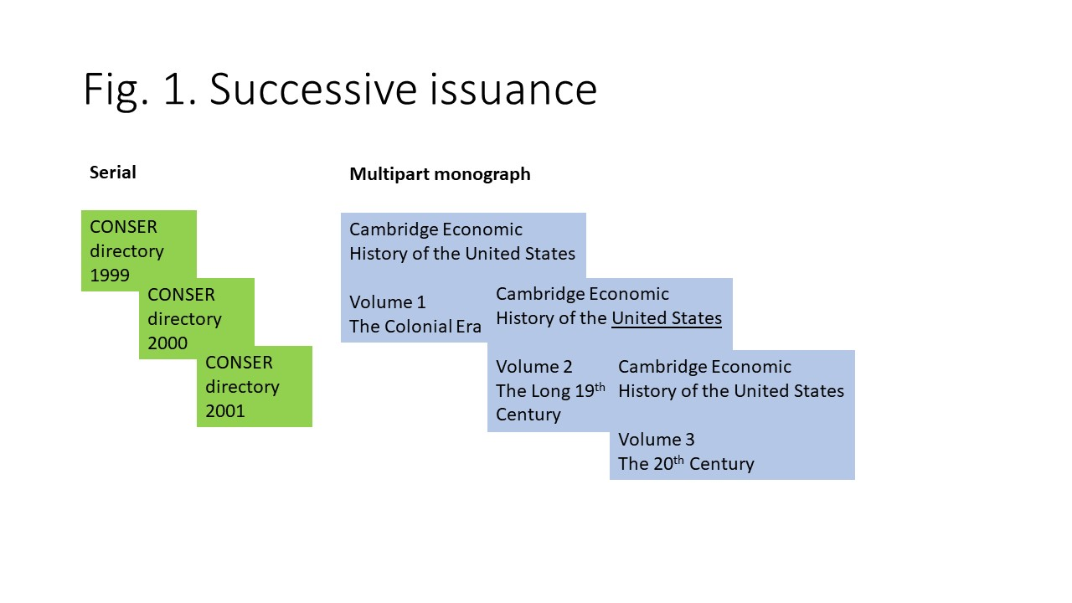
Figure 1 diagrams two kinds of resources issued successively. The fictitious print CONSER directory has separate issues, each of which has its own title and numbering. The content is updated annually and there is no predetermined conclusion. The mode of issuance is multiple units, and the extension plan is successive and indeterminate. Thus, it is a serial. The Cambridge Economic History of the United States is a monograph complete in three separate volumes, each with its own title and numbering. Its mode of issuance is multiple unit, and its extension plan is successive and determinate. This is a multipart monograph.

Integrating resources are updated over time; but the updated content is folded into the overall work and is not identifiable as a discrete update. This situation is easiest to imagine with a printed loose-leaf. While the updates may come on a regular basis with a cover sheet bearing numbering and dates, once the pages that comprise the update are interfiled into the base volume of the loose-leaf, the update no longer remains discrete. For electronic resources, such as updating databases, changes are made by the publisher and the way that the cataloger or user knows that a change has occurred is usually through a revision date.

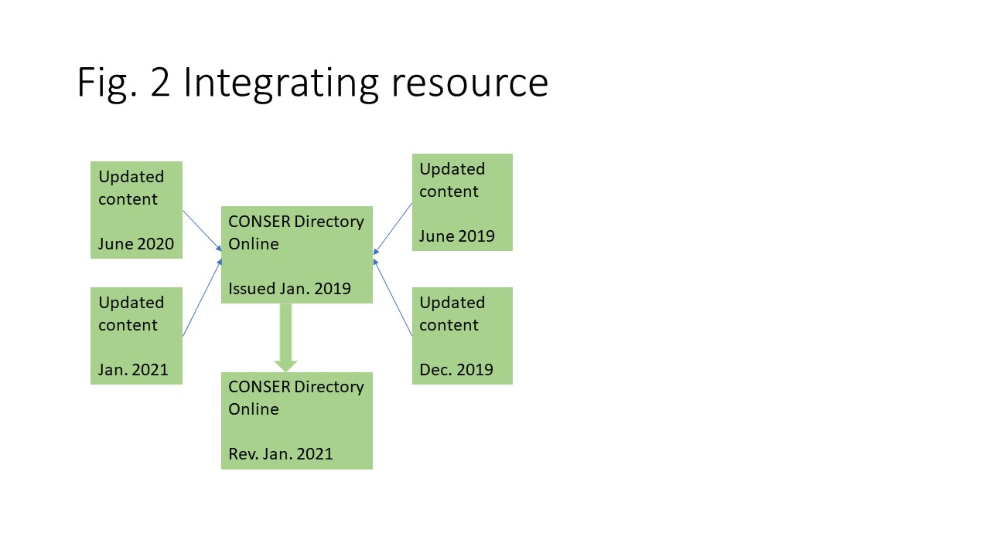
In Figure 2, the CONSER directory is issued in an online format. Updates to the content are added and the date of revision is changed accordingly. Its mode of issuance is multiple unit, and its extension plan is integrating and indeterminate.

These examples are obvious, but many resources are ambiguous or unclear about their mode of issuance and extension plan.

0.1.5. Basic differences between the description of serials and integrating resources
There are two very basic differences in the description of serials and integrating resources which are based on the form of issuance. These are the basis of the description and entry conventions. Serials are described from the earliest issue or part and changes are reflected in notes. When a major change occurs, a new description is made according to successive entry conventions. Integrating resources, on the other hand, are described from the latest iteration and earlier information is given in notes. Furthermore, most changes to integrating resources do not constitute major changes requiring a new description and are recorded as notes in the original description.

0.2. Continuing resources in RDA
While an integrating resource may be finite or continuing, there is little difference in the way in which it is cataloged. So, unless otherwise noted (e.g., RDA 1.6.3), rules that apply to serial will also apply to integrating resources.

0.3. Continuing resources and MARC records
The bibliographic level (leader/07) of the leader in the MARC 21 Format for Bibliographic Data contains codes used to specify whether a resource is a monograph (m), serial (s) or integrating resource (i). The continuing resources 008 fixed field is used for serials and integrating resources that are predominantly textual in content and coded type of record code “a” for language material.

Implementation of code “i,” for integrating resources was completed in June 2006. Legacy records for integrating resources may be coded according to an interim PCC policy that used bibliographic level “m” (monograph) and a continuing resources field 006 for the continuing aspects of the resource.

0.4. Continuing resources and the Program for Cooperative Cataloging (PCC)
The PCC includes two separate programs for the creation of bibliographic records: CONSER and BIBCO. CONSER has traditionally covered serials in all formats, while BIBCO covers monographs in all formats. Updating loose-leaf publications were traditionally cataloged by monograph catalogers. Both monograph and serial catalogers have cataloged electronic integrating resources, such as Web sites and databases. Thus, for PCC, integrating resources are covered by both programs. Both CONSER and BIBCO catalogers can create and maintain records for integrating resources and records for integrating resources are authenticated and distributed with the CONSER database.

0.5. Continuing resources in CONSER documentation
Both the CONSER Cataloging Manual and CONSER Editing Guide, include instructions relating to serials and integrating resources.

