Module 6. Title and Statement of Responsibility (Field 245)

Table of Contents
Module 6. Title and Statement of Responsibility (Field 245) 1
Table of Contents 1
Module 6. Title and Statement of Responsibility (Field 245) 3
Definitions of terms used in this module 3
6.1. Title proper 5
6.1.1. Definition and sources 5
6.1.2. Types of titles proper 5
6.1.3. Transcribing the title proper 6
a. Challenges of typography 8
b. Symbols 9
c. Inaccuracies 10
d. Punctuation 10
e. Capitalization 10
6.1.4. Multiple titles or representations of the title 11
a. More than one title representing separate works 11
b. One work, more than one title 12
c. Title in more than one language 13
d. Initialism and full form of title 13
e. Alternative title 16
6.1.5. Where does the title proper begin? 16
6.1.6. Where does the title proper end? 19
6.1.7. What to omit 21
a. Designations: numbers and/or dates 21
b. Names, numbers other than designations, and other data that are omitted 23
c. Distinctive titles 24
d. Earlier title of the serial 25
6.1.8. When there is no title 25
6.2. Common title and section title 27
6.2.1. Definitions 27
6.2.2. Types of constructions using subfields $a and $p 28
a. Each serial has a common title and section title 28
b. Series and subseries 29
c. Parent title and title of a supplement or other part. 29
6.2.3. Sources and layout 29
6.2.4. Multiple sections or designations 31
6.3. Other title information 32
6.3.1. Definition and source 32
6.3.2. Background 32
6.3.3. Other title information that should be transcribed 32
6.3.4. Other title information that may be transcribed in the title statement, given as a note, or omitted 33
a. Subtitles 33
b. Titles other than the title proper 35
6.4. Parallel title proper 36
6.4.1. Definition and sources 36
6.4.2. Recording parallel titles proper 36
6.4.3. Original title of a translation 37
6.5. Statement of responsibility 38
6.5.1. Definition and sources. 38
6.5.2. Background 38
6.5.3. Corporate bodies 38
6.5.4. Jurisdiction 40
6.5.5. Personal names 42
6.5.6. Titles of other serials 43
6.5.7. Subsequent statements of responsibility 43
6.6. Combining elements of the title statement 44
6.6.1. Common title/section title and other elements of the title statement 44
a. Other title information 44
b. Statements of responsibility 44
6.6.2. Parallel titles proper and other elements of the title statement 44
a. Other title information 44
b. Statements of responsibility 45
c. Common title/section titles 46
6.7. Changes to elements of the title statement other than the title proper 47
6.7.1. Other title information 47
6.7.2. Parallel titles proper 47
a. Added 47
b. Dropped 47
c. Order of parallel titles proper changed 47
d. Change in words 47
6.7.3. Statement of responsibility (RDA 2.4.1.10.2) 48
6.8. Further examples 49
Summary 53

Module 6. Title and Statement of Responsibility (Field 245)
The title of a serial is recorded in ISBD "area 1"of the description--the "title and statement of responsibility area." The MARC 21 terminology, as given in the CEG, is "title statement." For the sake of brevity, this area will be referred to as the "title statement."

The entire title statement is input in field 245. It always includes the title proper ($a), and may also include other title information and parallel titles proper ($b), and a statement of responsibility ($c). The title proper, itself, may consist of a common title ($a) and the title of a section or part ($p), and in some cases, the designation of the section or part ($n). Some serials (usually older ones) have an alternative title (included in $a).

This Module will discuss:

- The elements of the title statement and the sources from which they are recorded
- The selection of the title proper
- The construction of the title proper when it consists of a common title and a section title
- Types of other title information and situations in which they are recorded
- When and how to record parallel titles proper
- The identification and recording of the statement of responsibility
- How to combine various elements of the title statement
- Changes to elements of the title statement other than the title proper (for changes in the title proper, see Module 16)

Definitions of terms used in this module
Alternative title. A second part of a title proper that consists of two parts, each of which has the form of an independent title, joined by a word such as "or" or its equivalent in another language.
(RDA)

Common title. A title common to two or more works, each of which carries the title and/or designation of a section. (CCM) The same concept is defined in Series Traning for PCC Participants (May 2016 revision) as “the title common to all parts or sections” (session 9, page 5); in his book RDA and Serials Cataloging, Ed Jones calls the same concept the “common (overarching) title” (page 77).

Devised title. A title proper created by an agency preparing a description of a manifestation that bears no title itself and has no title associated with it that can be found in accompanying material, a published description of the manifestation, a reference source, etc. (RDA)

Other title information. A word, character, or group of words or characters that appears in conjunction with, and is subordinate to, a title proper of a manifestation. (RDA)

Parallel title proper. A title proper in another language or script. An alternative title in another language or script is treated as part of a parallel title proper. (RDA)

Section. A separately issued part of a manifestation, usually representing a particular subject category within the larger manifestation and identified by a designation that may be a topic, or an alphabetic or numeric designation, or a combination of these. (RDA)

Series. A group of separate manifestations related to one another by the fact that each manifestation bears, in addition to its own title proper, a collective title applying to the group as a whole with or without numbering or, a separately numbered sequence of volumes or issues within a series or serial. (RDA)

Statement of responsibility relating to title proper. A statement associated with a title proper of a manifestation that relates to the identification or function of agents responsible for the creation of, or contribution to the realization of, the intellectual or artistic content of a work.

Subseries. A series within a series, that is, a series that always appears in conjunction with another, usually more comprehensive, series of which it forms a section. Its title may or may not be dependent on the title of the main series. (RDA)

Subtitle. The explanatory part of the title following the main title. (American Library Association. Committee on Library Terms. A.L.A. Glossary Library Terms. Chicago : ALA, 1943)

Title. A word, character, or group of words or characters that names a manifestation or a work embodied in it. (RDA)

Title proper. A chief name of a manifestation, that is, a title normally used when naming a manifestation. An alternative title is treated as part of a title proper. (RDA)

6.1. Title proper
The title proper is the only part of the title statement that must be given in every record. The title proper is used as follows:

- As the default preferred title and authorized access point, in some cases, such as when a serial is a work without a creator, but is instead a compilation of works by different agents (RDA 6.27.1.4) and its title proper is unique to the catalog and therefore requires no distinguishing qualifiers created according to RDA 6.27.1.9.

- In links to related serials; however, it may be coupled with the authorized access point of a corporate body or a person (RDA 6.27.1.2), or replaced by an authorized access point for the serial work or expression that includes distinguishing qualifiers. (RDA 6.27.1.9)

- In determining if a major change in title has occurred; title changes are based solely on the title proper (RDA 1.6.2.3 and 2.3.2.12.2)

The authorized access point of a serial work or expression based on the title proper as described above can also be used to cite the serial in other files (e.g., union list, check-in) and to identify by means of a MARC Added Entry Field in the description of a different work or expression a relationship to this entity.

6.1.1. Definition and sources
RDA defines the title proper as:

A chief name of a manifestation, that is, a title normally used when naming a manifestation. An alternative title is treated as part of the title proper.

The title proper may consist of a word, phrase, acronym or initialism, the name of a corporate body, etc. Record the title proper from the preferred source of information (RDA 2.3.2.2), following the guidelines in CCM 3.2 for determining that source. If there is no title provided within the manifestation itself, take a title proper from one of the sources specified in RDA 2.2.4.

6.1.2. Types of titles proper
The title proper may consist of one of the following combinations:

- a title consisting of a single statement ($a)

Sports illustrated
Genes, chromosomes & cancer
Health sciences research

- a title and an alternative title (both $a)

Farmers’ museum, or, Literary gazette

- a common title and a section title ($a, $p)

Area wage survey. $p Washington, D.C.-Md.-Va. metropolitan area

- a common title with a section title and the designation for the section ($a, $n, $p)

Clinical and experimental hypertension. $n Part B, $p Hypertension in pregnancy

- a common title and a section designation ($a and $n)

Physical review. $n A

Most serials have a title consisting of a single statement. Alternative titles are rarely found on current serials. Titles consisting of a common title/section title are more frequently encountered than alternative titles and are covered separately under CCM 6.2.

6.1.3. Transcribing the title proper

Fig. 6.1
When transcribing the title proper, follow the general guidelines for recording titles and transcribe it as it appears on the source of information (RDA 2.3.1.4). Do not change the words, order of words, or the spelling (see footnote); however, you may change the punctuation and capitalization when necessary, as explained below. If the typography or layout of the words on the preferred source causes doubt about what the publisher intends the title to be, consult other presentations of the title in the piece, such as the masthead or editorial page (Fig. 6.1).

245 | 00 | $a Federal facilities environmental journal.



Fig. 6.2

In this example (Fig. 6.2) the title is unclear because it is given in conjunction with the corporate body. An examination of the masthead makes it clear that the title is Case design report.

245 | 10 | $a Case design report / $c Case Institute of Technology, Engineering Design Center, Research and Development.

When a letter or word is presented once but is intended to be read more than once (Fig. 6.3 and Fig. 6.4), repeat the letter or word (RDA 1.7.7).


Fig. 6.3

245 | 00 | $a Trade-marks journal = $b Journal des marques de commerce.


Fig. 6.4

245 | 00 | $a Government of Canada publications = $b Publications du gouvernement du Canada.


Fig. 6.5

a. Challenges of typography
While the order of words in the title proper cannot be changed, there may be words on the piece that precede the title proper. Such words may constitute other title information, a section title, a series, or a different representation of the title that has not been selected as the title proper. These words could also constitute a statement of responsibility. For this reason, first determine what each word or phrase represents. Record words in the title proper in the order given on the piece and transcribe the other elements as appropriate. In this example (Fig. 6.5), the title proper is Gas, even though it follows the subtitle High Octane Poetry. Note that the title in its proper configuration appears at the foot of the title page.

245 | 00 | $a Gas : $b high octane poetry.

Sometimes the typography makes it difficult to easily see the title. In the example below (Fig. 6.6), the title The “In the Mood Paper” appears only in the upper left corner while the corporate body is more prominent. In the next example (Fig. 6.7), the placement of the corporate body between “Illinois” and “update” makes it unclear what the exact title is. Since the title in the masthead reads “Illinois HWRIC Update” (not shown), the corporate body is retained in the title.

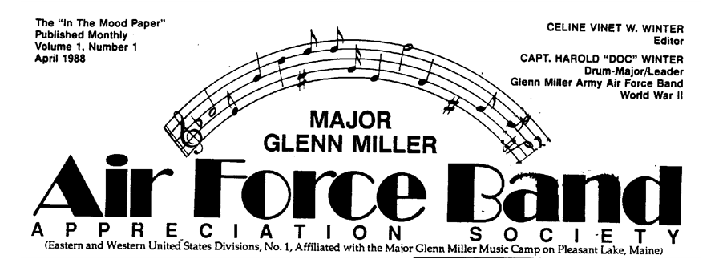
Fig. 6.6

245 | 05 | $a The "In the mood paper" / $c Major Glenn Miller Air Force Band Appreciation Society.


Fig. 6.7

245 | 00 | $a Illinois Hazardous Waste Research and Information Center update.
246 | 1# | Illinois update
246 | 1# | Illinois HWRIC update

b. Symbols
If the title includes a sign, symbol, or other graphic representation not available in the character set, use if possible techniques such as those illustrated in LC-PCC PS 1.7.5 to convey the intention. Some of the techniques involve substituting, if appropriate, the sign, symbol, or other graphic representation with its obvious spoken/written equivalent, or with an explanation or description of it. Indicate that the text of this substitution was taken from a source outside the resource itself by enclosing the supplied word or words in brackets.

On piece: | I ♥ Santa Fe guide book
In record: | 245 | 00 | $a I [love] Santa Fe guide book.
 | 588 | ## | $a On title page and cover "love" is represented by a heart symbol.

c. Inaccuracies
If obvious typographic errors appear in the title as given on the preferred source of information, give the corrected form in the title proper, and make a note (246 0$) recording the title as it appears in the source of information (exception to RDA 2.3.1.4). Record as a variant title access point (246 1$) the uncorrected title as it appears on the source of information, if considered important for access; in this case, the 246 doubles as a note. In case of doubt as to whether the spelling is correct, transcribe it as found.

245 | 00 | $a World report.
246 | 1# | Misspelled title on issue for 1988: $a Wrold report
362 | 1# | Began with: 1988.

d. Punctuation
Generally, transcribe punctuation as it appears on the source (RDA 1.7.3). This practice differs from past cataloging codes. Often when following AACR2 catalogers would change punctuation if it could be confused with ISBD punctuation.

e. Capitalization
According to LC-PCC PS A.1, catalogers are encouraged (but not required) to follow RDA Appendix A for capitalizing transcribed elements such as titles. If following the encouraged approach, capitalize words in the title according to RDA A.4.1. Always capitalize the first word in the title. Capitalize other words within titles by applying the guidelines at RDA A.10-A.55, as applicable to the language involved.

1) When the title consists of a common title and the title of a part, section, or supplement (see CCM 6.2), capitalize the first word in the part, section, or supplement title (RDA A.4.1). If a designation of a part ($n) begins with a word, capitalize the word.

245 | 00 | $a Journal of chemistry. $p Organic chemistry.
245 | 00 | $a American men and women of science. $p The medical sciences.
245 | 00 | $a Clinical and experimental hypertension. $n Part B, $p Hypertension in pregnancy.

2) Capitalize the first word of a title embedded within another title.

245 | 00 | $a Supplement to The journal of the Friends Historical Society.

3) If the serial is the result of a merger of two serials, however, and both titles are represented in the title proper, do not capitalize the title of the second serial (RDA A4.3).

245 | 00 | $a Farm chemicals and crop life.

4) Capitalize the first word in an alternative title.

245 | 04 | $a The literary gazette, or, Journal of criticism, science, and the arts.

Further examples of capitalization in the title proper:

245 | 10 | $a Proceedings of the ... International Convention of the United Electrical, Radio, and Machine Workers of America.
245 | 04 | The Mailbox Club messenger.
245 | 00 | WordPerfect report.
245 | 14 | ... annual report to the Governor.

While RDA gives explicit instructions for transcribing the title proper, the actual choice of the title proper, when there is more than one or when the title is ambiguous, is left to the cataloger. For most serials, the title proper is obvious. In other situations, however, the decision must be made as to where to begin or end the title proper or which of several different representations to select as the title proper.

The following sections provide instructions and considerations to be applied in determining the title proper. Keep in mind, however, that if a publisher clearly presents the title in one fashion on the preferred source, that form is transcribed as the title proper, even though the publisher may call the publication something else in another source. This frequently occurs with words such as "magazine" or "newsletter" which appear with the title in one source and not in another.

6.1.4. Multiple titles or representations of the title

a. More than one title representing separate works
If a serial includes two or more works, each with its own title (on the same source or on different sources) and there is no collective title, apply RDA 2.3.2.9. If one corporate body is responsible for all of the works (i.e., there is one statement of responsibility), give all of the titles as the title proper, separating each by a space-semicolon-space ( ; ). Give a variant title (field 246) for the title(s) after the first. For instructions on recording the designation when there is more than one, see CCM Module 8.

On piece: | Overview of programs for fiscal 1990  Annual report for fiscal 1989  Japan Foundation
In record: | 110 | 2# | $a Kokusai Kōryū Kikin
 | 245 | 10 | $a Overview of programs for fiscal ... ; $b Annual report for fiscal ... / $c Japan Foundation.
 | 515 | ## | $a Annual report covers the previous year.
 | 588 | ## | $a Description based on: 1990; title from title page.
 | 740 | 02 | $a Annual report for fiscal ...

When different bodies are responsible for the works, if recording statements of responsibility give each title followed by its related statement of responsibility. Separate each with a period.

On piece (separate sources):
Dynamit Nobel Aktiengesellschaft
Report on the business year 1963

Feldmühle Aktiengesellschaft
Report on the business year 1963
In record: | 110 | 2# | $a Dynamit Nobel AG.
 | 245 | 10 | $a Report on the business year ... / $c Dynamit Nobel Aktiengesellschaft. Report on the business year ... / Feldmühle Aktiengesellschaft.
 | 710 | 2# | Feldmühle Aktiengesellschaft. $t Report on the business year ...

Note that a variant title for the second title (Field 246) is unnecessary in this example because it is identical to the title in Field 245. An author/title access point (Field 710) is more appropriate. For further instructions on variant access points, see CCM Module 7.

COLLECTION AGENCY
REPORT

Collection Agency
Directory

1st edition

The definitive Guide
to the
Collection Agency Industry
in North America

Fig. 6.8

b. One work, more than one title
When there is only one work in the serial, and the preferred source has separate words or phrases, each of which could be construed to be the title proper, select one as the title proper. First be sure that one of the titles isn’t an unnumbered series (searching the LC/NACO Authority File could help determine this). To determine which should be the title proper, consult other sources in the serial and consider the nature of each title. Does one qualify or further explain the other or are they equally independent of each other? In the latter case, consider whether one is more typographically prominent than the other.

In Fig. 6.8., there are two separate titles, each of which could be the title of the serial. Because the title Collection Agency Directory is more prominent on the preferred source, it is chosen as the title proper. In this case, the cataloger has chosen to record the other title in an "At head of title" note. It could also be recorded as other title information (see CCM 6.3.3.).

245 | 00 | $a Collection agency directory.
246 | 1# | $i At head of title: $a Collection agency report

c. Title in more than one language
If a title is given on the preferred source in more than one language, select as the title proper the title in the language that comprises the main portion of the serial (RDA 2.3.2.4). If the text is equally divided or it is difficult to determine, choose the first title that appears on the piece. CONSER catalogers will most often apply the latter provision of the rule (i.e., choosing the title from the order given). However, in cases where the first title given is in a language not represented in the text (e.g., Latin or Greek), it is best to choose another title.

d. Initialism and full form of title
When an acronym or initialism appears on the preferred source in addition to the spelled out or "full form" of the title, use the full form as the title proper (RDA 2.3.2.5 and its LC-PCC PS) and record the acronym or initialism as variant titles.

Prior to the 2002 revision of AACR2, when both the full form and initialism appeared on the chief source, the acronym/initialism was transcribed as the title proper when it was the only form of the title given in other sources. The change was made to harmonize practices with ISSN. According to CONSER practice, do not change existing records where the acronym or initialism is the title proper, even when doing so might avoid a major change.

In Fig. 6.9, the full form is the title proper even though the initialism is typographically prominent.

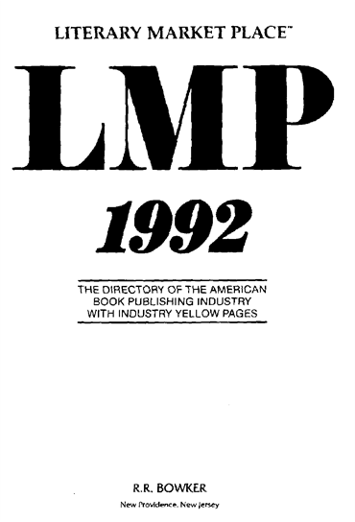
Fig. 6.9

245 | 00 | $a Literary market place : $b LMP.
246 | 1# | $a LMP


Fig. 6.10a
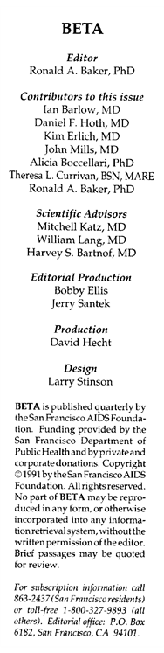
Fig. 6.10b

In Fig. 6.10a-b, while the acronym "BETA" is presented in other areas, the full form is chosen as title proper according to RDA 2.3.2.5. Note that in this case two types of other title information are given (the second statement appears directly below the title on the chief source).

245 | 00 | $a Bulletin of experimental treatment for AIDS : $b BETA : a publication of the San Francisco AIDS Foundation.
246 | 1# | $a BETA

If, however, the full form and initialism do not appear on the same source, the one appearing on the preferred source is the title proper and the one appearing on another source is given as a note (Field 246); do not record as other title information.

On piece: | TDR
On spine: | The drama review
In record: | 245 | 00 | $a TDR.
 | 246 | 1# | $a Drama review

Apply RDA 2.3.2.5 also when the initialism and full form are not exactly the same:

245 | 00 | $a American book publishing record : $b BPR

Or when the acronym is embedded in the title:

245 | 00 | $a Mathematics teacher education & development : $b mted.
246 | 1# | Mted
[On piece, the acronym is embedded in the title, i.e. the first letter of the words are colored to form the acronym of the title.]

Note: Do not confuse letters that represent the corporate body with initialisms of the title. For example, in the title ORALL newsletter, "ORALL" stands for the corporate body – Ohio Regional Association of Law Libraries – not the title (Fig. 6.11).

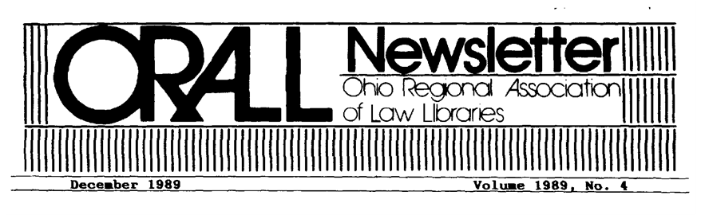
Fig. 6.11

Apply this instruction also when an additional word or words appears with the initialism (Fig. 6.12).

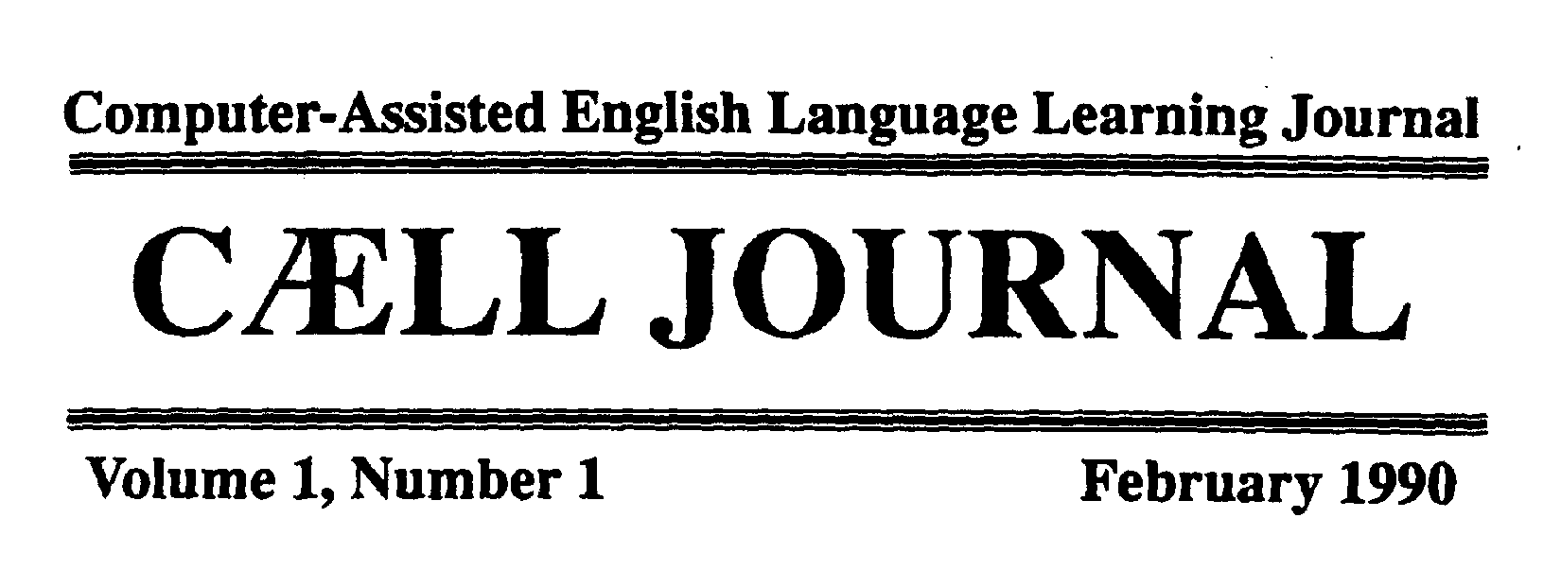 | 
Fig. 6.12

245 | 00 | $a Computer-assisted English language learning journal : $b CAELL journal.
246 | 1# | $a CAELL journal.
246 | 1# | $a Computer assisted English language learning journal

e. Alternative title
An alternative title is a second, equally independent title that appears with the first title and is preceded by the word "or" or its equivalent in another language. Alternative titles are most often found on 19th and early 20th century serials; they are rarely encountered on current serials.

Give both titles as the title proper, separated by commas (Fig. 6.13). Create added entries (fields 246) for both the alternative title and the first title without the word “or.”. (RDA 2.3.6 and LC-PCC PS for 2.3.6.3 section D.1).


Fig. 6.13

245 | 00 | $a Farmers' museum, or, Literary gazette.
246 | 1# | Literary gazette
246 | 1# | Farmers' museum

6.1.5. Where does the title proper begin?
Names and words that appear on the same line with the title are generally transcribed as part of the title (e.g., Fiscal year 1992 program report would be 245 10 Fiscal year ... program report). In order to determine whether the name of a person, corporate body, or another serial that appears above the title is part of the title proper, consider first whether the name is grammatically linked to the title.

- If the name is linked by the use of an apostrophe or a grammatical case ending, include the name in the title proper, according to RDA 2.3.1.5.
- However, words that serve as an introduction to the title, such as “welcome to...,” “presents...,” should be omitted according to RDA 2.3.1.6.


Fig. 6.14

In both of these examples (Fig. 6.14), the name of another serial is given. The use of the word “presents” in the first example makes it possible to interpret this statement as introductory wording that can be omitted. In the second example, however, the name of the other serial is given alone and is grammatically linked and, thus, is transcribed as part of the title.

245 | 00 | $a Muscle car and truck buyer's guide.
246 | 1# | $i Title appears on item as: $a Price guide presents-- muscle car and truck buyer's guide
245 | 00 | $a Political pulse's education beat.
246 | 1# | $i Education beat

Names of bodies, persons, or other publications that are not grammatically linked may be transcribed in or omitted from the title proper, depending on the nature of the name, its proximity to the title, and the presentation of the title in other sources. When in doubt, consider other presentations of the title that are given in the serial (RDA 2.3.1.5).

For example, a corporate body that appears above the title without a grammatical link may be included in the title proper or transposed as the statement of responsibility. When unsure whether to include the name in the title, look to see if the title appears elsewhere, with or without the name of the corporate body. Consider formal statements found on the editorial page, cover, etc. rather than informal statements appearing in the preface or text.

In Fig. 6.15, the cataloger has chosen not to include the corporate body in the title, probably due to the typography.

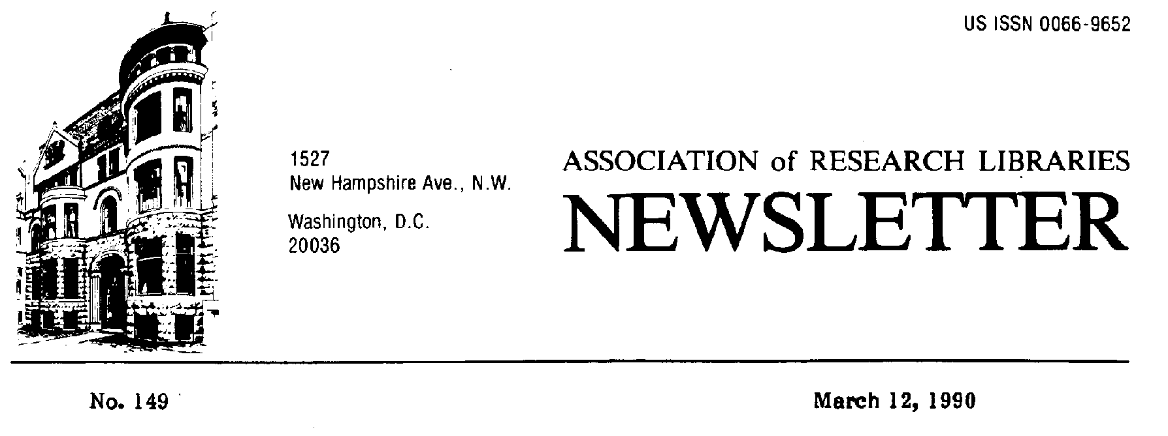
Fig. 6.15

110 | 2# | $a Association of Research Libraries.
245 | 10 | $a Newsletter / $c Association of Research Libraries.
246 | 1# | $a ARL newsletter
246 | 1# | $a Association of Research Libraries newsletter

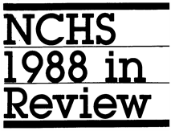
Fig. 6.16
In Fig. 6.16, the acronym of the corporate body appears more as an integral part of the title. The cataloger has included the name in the title.

245 | 10 | $a NCHS ... in review.


Fig. 6.17
The decision to include or not include the name of the body in the title is not as critical as it once was since a change on a later issue in the placement of the body is considered to be a minor title change and does not require a new record (RDA 2.3.2.13.2.c). In the past, catalogers avoided putting the corporate body in the title (see also Module 16).

In Fig. 6.17, the title could be transcribed as "Annual report" or "Prince Edward Island Energy Corporation annual report" since the title is typographically indistinguishable from the corporate body.

110 | 2# | $a Prince Edward Island Energy Corporation.
245 | 10 | $a Annual report / $c Prince Edward Island Energy Corporation.
246 | 1# | $a Prince Edward Island Energy Corporation annual report

or

110 | 2# | $a Prince Edward Island Energy Corporation.
245 | 10 | $a Prince Edward Island Energy Corporation annual report.
246 | 1# | $a Annual report

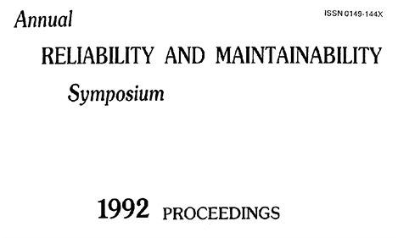
Fig. 6.18

When cataloging conference publications, remember that the name of the conference constitutes the statement of responsibility in most cases when there is a title proper. In Fig. 6.18., the title is "Proceedings."

111 | 2# | $a Reliability and Maintainability Symposium.
245 | 10 | $a ... proceedings / $c Annual Reliability and Maintainability Symposium.

6.1.6. Where does the title proper end?
The title proper can be short or long.

245 | 00 | $a Ms.
245 | 00 | $a New York State's list of approved in-state private schools and special act school districts for children with handicapping conditions and out-of-state schools with New York State contracts.

In general, do not abridge a serial title. RDA 2.3.1.4, which allows a long title proper to be abridged, is generally used only for older, pre-20th century works on which the title often covered the entire title page.

Record phrases that are grammatically linked as part of the title proper, even though a secondary phrase may seem more like other title information or may incorporate the name of a responsible corporate body.

245 | 00 | $a Fees and taxes charged insurance companies under the laws of New York together with abstracts of fees, taxes, and other requirements of other states for ...

not

245 | 00 | $a Fees and taxes charged insurance companies : $b under the laws of New York together with abstracts of fees, taxes, and other requirements of other states for ...
[even though the first part of the statement is in larger type]


Fig. 6.19
Is the phrase "from Oregon Graduate Center" part of the title or should it be recorded as a statement of responsibility? In the masthead the title is given as "Visions" (Fig. 6.19). We might think of “from” as similar to the word “of” and transcribe the whole phrase as part of the title. A 246 field should be given in this case for the word “Visions” alone.

245 | 00 | $a Visions from Oregon Graduate Center.
246 | 1# | $a Visions

IMAGES
for the new generation

Fig. 6.20
In this example (Fig. 6.20), the words "for the new generation" indicate the audience of the serial and the phrase is included in the title. An added entry is given for "Images" alone because it is typographically prominent.

245 | 00 | $a Images for the new generation.
246 | 1# | $a Images

The phrase "Covering the gas and gas liquids industry worldwide," which is set apart by typography, explains the nature of the contents and thus, might qualify as other title information (Fig. 6.21). This is the type of phrase that could be included in a quoted note.

INTERNATIONAL
GAS REPORT
covering the Gas and Gas Liquids Industry Worldwide

Fig. 6.21

245 | 00 | $a International gas report.

Occasionally, the title page of a serial includes a phrase that indicates the inclusion of another work. Consider whether each issue of the serial is likely to include this work when determining whether to record the phrase in the title proper. If the phrase is omitted, it may be given in a note (see also CCM 6.1.7.d.).

On piece: | Annual report 1974  including report of the proceedings of the annual conference held on 3rd, 4th, 5th, and 6th June 1973
In record: | 245 | 10 | $a Annual report.
 | 500 | ## | $a Reports for <1974-> include the Report of the proceedings of the annual conference.
 | 740 | 02 | $a Report of the proceedings of the annual conference.

6.1.7. What to omit (exceptions to RDA 2.3.1.4)

Omit information that is specific to one or several issues. Such information includes designations (i.e., numbers or dates) that vary from issue to issue and names of persons that are likely to change on a frequent basis.

a. Designations: numbers and/or dates
In most cases, a number or date found at the beginning, end, or middle of a title constitutes the issue's designation and is omitted from the title statement. Record the omitted designation, including associated words or phrases, in the numbering area (field 362) or in the "Description based on" note (see Module 8).

On piece: | 1989 Report of the Statistical Reporting Service
In record: | 245 | 10 | $a ... report of the Statistical Reporting Service.
 | 588 | ## | $a Description based on: 1989; title from title page.

On piece: | 5th Directory of services covering 1988/89
In record: | 245 | 10 | $a ... directory of services covering ...
 | 588 | ## | $a Description based on: 5th (1988/89); title from title page.

Omit the number or date when it varies from issue to issue and, depending on where the omission occurs, replace the omitted data with the mark of omission (...) (RDA 2.3.1.4). If the omission occurs at the end, do not use the mark of omission unless the date or number omitted was grammatically linked to the rest of the title. A grammatical link is a word such as "for" or "in" that links the title to a date, number, or a phrase that contains the date or number. When the mark of omission is given at the end of the title statement, do not give an additional period.

On piece: | 1989 Annual report
In record: | 245 | 00 | $a ... annual report.

On piece: | Annual report for 1989
In record: | 245 | 10 | $a Annual report for ...

On piece: | Annual report  Fiscal year 1989
In record: | 245 | 10 | $a Annual report.
 | 588 | ## | $a Description based on: Fiscal year 1989; title from cover.

On piece: | Memoria 1988
In record: | 245 | 10 | $a Memoria.

On piece: | Washington State 1989 budget and statement of accounts
In record: | 245 | 10 | $a Washington State ... budget and statement of accounts.

Omit all words and numbers that constitute the chronological designation from the title (RDA 2.3.1.4).

On piece: | Annual report for the fiscal year 1 July 1990 through 30 June 1991
In record: | 245 | 10 | $a Annual report for the fiscal year ...
 | 588 | ## | $a Description based on: 1 July 1990 through 30 June 1991; title from cover.

If there is more than one number/date omitted from different places in the title, use an ellipsis for each. See Module 8 and RDA 2.6.7.3 for information on recording multiple chronological designations.

On piece: | Outlook for 1989 and report for 1988
In record: | 245 | 10 | $a Outlook for ... and report for ...
 | 515 | ## | $a Outlook for <1989-> includes report for <1988->.
 | 588 | ## | $a Description based on: 1989; title from title page.

Retain numbers or dates in the record when:

1) the number or date is an integral, unchanging part of the title.

245 | 00 | $a 73 magazine for radio amateurs.
245 | 00 | $a 12-year stock record.

2) the number remains constant on each issue and designates a section title (CCM 6.2.).

b. Names, numbers other than designations, and other data that are omitted
When the title includes data, such as names or numbers (other than designations), that are likely to change frequently, even if not on every issue, omit the data from the title. Examples of such omissions are names of officials and prices that relate to the title.

On piece: | The report of Governor Robb to the State Legislature  {made up example}
In record: | 245 | 14 | $a The report of Governor ... to the State Legislature.

On piece: | Frommer's guide to Washington, D.C. on $35 a day
In record: | 245 | 00 | $a Frommer's guide to Washington D.C. on $... a day.


Fig. 6.21

245 | 00 | $a Investment review of ordinary shares in ... Australian companies.
500 | ## | $a Title varies slightly.
500 | ## | $a Number of companies varies with each issue.

c. Distinctive titles
Some serials, in addition to having a title common to all issues, also have additional titles that reflect the theme or subject of the individual issue. The additional title is called a "distinctive title." Distinctive titles are not usually recorded because adding each new title to the record would be impractical; however, a note may be given to indicate the presence of distinctive titles on the piece (RDA 2.17.2.4), e.g., Each issue also has a distinctive title.



Fig. 6.22

"New directions in production and presentation technology" is a distinctive title because it represents the focus of this issue (Fig. 6.22). From the presentation on the chief source it could be considered to be part of the title proper, but an examination of the title in other sources shows that the title proper is AV video. The distinctive title is not given in the record, but a general note is given.

245 | 00 | $a AV video.
500 | ## | $a Some issues have distinctive titles.

d. Earlier title of the serial
Occasionally, when the title of a serial changes, the earlier title is included on the piece with the new title to alert readers to the fact that this is the same serial. This also occurs when one serial absorbs another and the publisher wishes the reader to be aware of this fact. After a period of time, the earlier title is usually dropped. For this reason, omit the earlier or absorbed title from the title proper (RDA 2.3.1.4), but record it in linking entry field 780.

On piece: | International gas report, incorporating World gas report
In record: | 245 | 00 | $a International gas report.
 | 780 | 05 | $t World gas report
 | {2nd ind. 5 = Absorbed}

6.1.8. When there is no title
RDA 2.3.1.5 allows for the name of a person or corporate body to be given as the title proper when there are no other words that could be construed as the title. For serials, this situation often occurs with conference publications when the name of the conference alone appears on the preferred source or with administrative reports that contain only the name of the corporate body on the preferred source. When a name is given as the title proper, you can give a summary of the contents using a 520 field, e.g., Proceedings of the Conference. When possible, use words found elsewhere in the piece.


Fig. 6.23
Apply RDA 2.3.2.103 only when no title is found prominently in the item. For example, if a title appears on the cover and the page that would normally be the title page contains only the name of a corporate body, choose the cover as the title page substitute. The other page is not considered to be a title page because there is a title and it is not included on this page (see Module 3).

In the rare instances when there is no title page or other page that could be used as a title page substitute, take the title from other issues (when available), or from a reference source (RDA 2.3.2.10 and 2.3.2.11 and LC-PCC PS for 2.3.2.11). Give the title within brackets. Cite the source in field 500 (e.g., Title from text; Title from [reference source], etc.). If a title can't be found in any of these sources, supply a brief title within brackets.

In Fig. 6.23, there is no true title, only the name of the corporate body. The name of the body is given as the title proper.

110 | 2# | $a Hawaii Institute of Geophysics.
245 | 10 | $a Hawaii Institute of Geophysics.
520 | ## | $a Report of the Institute.

6.2. Common title and section title
When a publisher issues a group of serials under the same "common" title and gives each serial in the group a "section" title, both titles are given as part of the title proper, provided that both titles appear on the same source (RDA 2.3.1.7.1 and exception to RDA 2.3.1.7.2). If the section title is given a numeric or alphabetic designation, the designation is also included in the title proper. Note that this designation is not the numbering for the serial (see Module 8) but a designation for the section that remains constant on each issue (e.g., Part A).

When the common title and section title are not grammatically linked, record the titles in the following construction, regardless of the order of titles on the piece.

$a Common title. $p Section title.
$a Common title. $n Designation.
$a Common title. $n Designation, $p Section title.

When the two titles are grammatically linked, record the title as a simple title proper.

245 | 00 | $a Weather forecasts for New England  {made up example}
245 | 00 | $a Weather forecasts for New York

See also the LC-PCC PS for RDA 0.0: Determining Number of Records / Serials Issued in Parts.

Note also that in the module for integrating resources (Module 35, section 2.2.1.5) there are guidelines for handling common titles vs. unnumbered series titles and the problems presented when cataloging online integrating resources.

For a discussion on the edition statement vs. common title/section title, see Module 9.

6.2.1. Definitions
RDA defines a section as:

A separately issued part of a manifestation, usually representing a particular subject category within the larger manifestation and identified by a designation that may be a topic, or an alphabetic or numeric designation, or a combination of these.

Although there is no official definition of a common title, for purposes within this manual it is defined as:

A title common to two or more works, one or more of which also carries the title and/or designation of a section.

6.2.2. Types of constructions using subfields $a and $p
Three types of situations occur for serials.

a. Each serial has a common title and section title
This occurs when a publisher issues a series of publications on particular topics, geographical breakdowns, etc., that are parts of a larger topic.

245 | 00 | $a Daily report. $p Western Europe.
245 | 00 | $a Daily report. $p People's Republic of China
245 | 00 | $a From the state capitals. $p Agriculture and food products.
245 | 00 | From the state capitals. $p Federal action.
245 | 00 | From the state capitals. $p Fire administration trends in the states.

Serials of this type may also be designated by a number or letter. (RDA 2.3.1.7.1)

245 | 00 | $a Proceedings of the Institution of Mechanical Engineers. $n Part A, $p Power and process engineering
245 | 00 | $a Proceedings of the Institution of Mechanical Engineers. $n Part B, $p Journal of engineering manufacture.

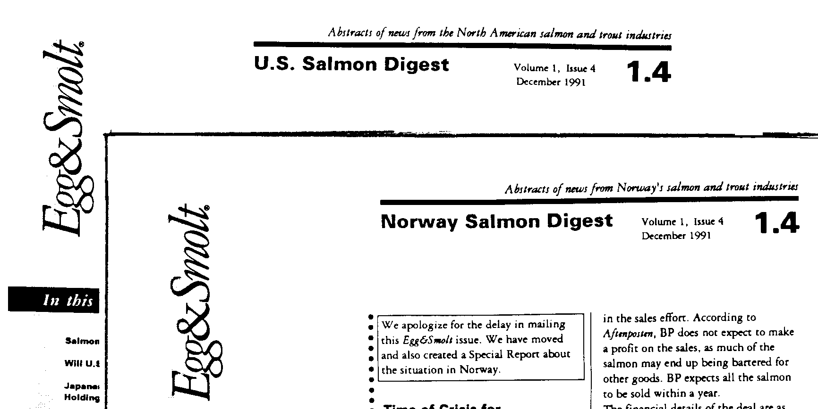
Fig. 6.24

245 | 00 | $a Egg & smolt. $p U.S. salmon digest.
246 | 1# | $a U.S. salmon digest
245 | 00 | $a Egg & smolt. $p Norway salmon digest.
246 | 1# | $a Norway salmon digest

b. Series and subseries
A series/subseries situation is one in which there are three titles on the piece--a series, a subseries (or series within a series) and the title of the individual piece, or "analytic." (See also CCM Module 12 and Series Training for PCC Participants, Session 9: Subseries, December 2015 revision).

On piece: | Five year plan  Department of State publication no. 8888  East Asian and Pacific series no. 989
In record for East Asian and Pacific series:
 | 245 | 00 | $a Department of State publication. $p East Asian and Pacific series.

c. Parent title and title of a supplement or other part.
This is not a common title/section title situation but the construction is the same. In this situation, a serial is issued on its own and also has a supplement (or other subordinate part) that bears the title of the parent serial plus the generic term "supplement" (or its equivalent). The two titles are not grammatically linked.

Parent serial: | British Journal of Psychiatry
Supplement: | British Journal of Psychiatry  Supplement no. 1
In records: | 245 | 00 | $a British journal of psychiatry.
 | 245 | 00 | $a British journal of psychiatry. $p Supplement.

6.2.3. Sources and layout
The common title and section title must be found on the same source in order to be recorded as the title proper. In the rare cases when both titles are not found on the preferred source, it is CONSER best practice to continue to follow the instructions given in LCRI 12.1B4 (available in Cataloger’s Desktop) and to consider all presentations of the common title and section title on the title page and preliminaries, and if any one gives both, to consider that as the preferred source.

This best practice concerning sources maintains consistency between the instructions for serials that are not series with those in LC-PCC PS 2.12.10.2 for the title proper of a main series/subseries. Such alignment facilitates creating descriptions in situations when a non-series serial with a common title/section title becomes a main series/subseries and vice versa. It also maintains a degree of practical correspondence with the instructions in the ISSN Manual, section 5.3.

If there is no source on which both the common title and the section title appears, apply RDA 2.3.1.7 and give the section title as the title proper and the common title as part of a series statement or as a title of a related work, depending on other information. If in doubt, it is a CONSER best practice to consider the common title as part of a series statement.

 | 
Fig. 6.25a | Fig. 6.25b

In Fig. 6.29a., the section title "Livres" appears only on the cover which is chosen as the preferred source.

245 | 00 | $a Bibliographie nationale français. $p Livres : $b notices établies par la Bibliothèque nationale.
246 | 1# | $a Livres
588 | ## | $a Description based on 1990, no 2 (17 janvier 1990); title from cover.

6.2.4. Multiple sections or designations
Some serials have a title proper consisting of multiple sections and/or designations. The number of sections or designations that can be recorded is not limited.

245 | 00 | $a Proceedings. $n A. $n Part 1, $p Chemical sciences.
245 | 00 | $a Fact book. $p Philippine financial system. $p Supplement.
245 | 00 | $a Current housing reports. $n Series H-150, $p Annual housing survey, United States and regions. $n Part A, $p General housing characteristics.

6.3. Other title information
If a word or phrase is not included in the title proper, consider if such a word or phrase constitutes other title information, and if it does, whether it should be transcribed in the title statement as instructed in LC-PCC PS 2.3.4.

6.3.1. Definition and source
RDA defines other title information as:

A word, character, or group of words or characters that appears in conjunction with, and is subordinate to, a title proper of a manifestation.

With the exception of devised titles, record other title information only from the same source as the title proper (RDA 2.3.4.3). Statements that would normally constitute other title information that are found only on other sources may be given in a note.

6.3.2. Background
The concept of "other title information" was introduced in AACR2. Under earlier rules, subtitles were sometimes given in quoted notes (field 500) and sometimes in the title statement (245 $b). When AACR2 was first implemented, CONSER adopted an "augmented level one" description for serials which prohibited the recording of other title information, except in certain circumstances. The prohibition sought to keep extraneous information from cluttering the title statement, particularly because this information is likely to change. Subsequently, the restriction was loosened to enable recording of other title information that was considered useful for the identification of the serial. With the revision of AACR2 Chapter 12 in 2002, a rule listed the situations in which other title information must be given and allowed the cataloger to decide what to do in other cases.

In RDA other title information is not a core element; however, in the CONSER Standard Record it is a “core if” element for PCC: “Record if it provides clarification or support to the title proper that otherwise might appear misleading without the other title information.” (CONSER Standard Record 2.3.4)

6.3.3. Other title information that should be transcribed
According to RDA there is only one situation where the other title information is transcribed:

The statement of responsibility is embedded in the other title information (RDA 2.3.1.5)

245 | 00 | $a Ellinokos horos and traditions : $b a newsletter of the Greek International Folk Dance Federation.
245 | 00 | $a Espacio y desarrollo : $b boletin del C.I.G.A.
245 | 00 | $a Field notes : $b newsletter of the Arkansas Archeological Society.


Fig. 6.26

245 | 00 | $a Catalogue & index : $b periodical of the Library Association Cataloguing and Indexing Group.

6.3.4. Other title information that may be transcribed in the title statement, given as a note, or omitted

a. Subtitles
The most common type of other title information found is the subtitle. While RDA does not define a subtitle, the term is defined in the ALA Glossary as the explanatory part of the title following the main title.

On piece: | Montana  The magazine of Western history
On piece: | Chronicles  A magazine of American culture
On piece: | Food production management  The publication on growing, processing, packaging, distribution
On piece: | Linguistics  A monthly review

Use judgment when considering whether to include other title information in the record. The reason that it was not generally given prior to AACR2 and that its use has been restricted more recently is that it is the type of information that is likely to change.


Fig. 6.27

245 | 00 | $a Psychotherapy today

In Fig. 6.27, the phrase "The independent psychotherapy newsletter" adds little to the title and has been omitted.

On piece: | Monoclonal antibodies: a quarterly publication containing availability of new monoclonal antibodies for all researchers.
In record: | 245 | 00 | $a Monoclonal antibodies.

On piece: | Linguistics: a monthly review.
In record: | 245 | 00 | $a Linguistics.

The exception in RDA 2.3.4.3 instructs to record information about the currency of the contents or the frequency of updating as frequency.

There are times, however, when other title information can be very useful in helping to identify a serial with a title that is not very explanatory. In such cases, consider how the title will display in browse listings in the catalog and whether it is preferable to record the information in a quoted note (500) or within the title statement. The decision is up to the cataloger.

245 | 00 | $a Montana : $b the magazine of Western history.
245 | 00 | $a Computers and libraries : $b an Australian directory.
245 | 00 | $a Dialogue.
500 | ## | $a “A journal of Mormon thought.”
245 | 00 | $a Camera obscura
500 | ## | $a “A journal of feminism and film theory.”

b. Titles other than the title proper
This type of other title information may be thought of as the equivalent of an "alternative title" without the preceding word "or." In such cases, both titles are independent of each other and either one might be chosen as the title proper. Neither explains the other. (See also CCM 6.1.4.b. and Fig. 6.8.)

On piece: | Super television  Camcorder report
In record: | 245 | 00 | $a Super television : $b camcorder report.
 | 246 | 1# | $a Camcorder report


Fig. 6.28

In Fig. 6.28, either title could stand alone as the title of the serial.

245 | 00 | $a Teddy Bear artist's annual : $b who's who in bear making
246 | 1# | $a Who's who in bear making

6.4. Parallel title proper
When the title on the preferred source appears in two or more languages, one is chosen as the title proper (RDA 2.3.2.4; see CCM 6.1.4.c); the remaining titles are parallel titles proper (RDA 2.3.3.1).

6.4.1. Definition and sources
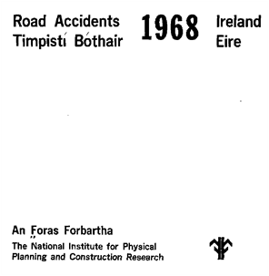
Fig. 6.29
RDA defines a parallel title proper as the title proper in another language and/or script.

In Fig. 6.29, two titles are given, one in English and one in Irish. Since the English title is recorded as the title proper, the Irish title is recorded as the parallel title proper. Parallel titles proper in a serial record may be recorded in a variant title field (MARC field 246 11); it is not necessary to also record it in a subfield in the main title field.

245 | 00 | $a Road accidents, Ireland = $b Timpisti bothair, Eire.
246 | 11 | $a Timpisti bothair, Eire

Although a parallel title proper is usually a one-to-one translation of the title proper, this need not always be the case. (See also Fig. 6.51.)

245 | 04 | $a The European journal of surgery = $b Acta chirurgica.
246 | 11 | $a Acta chirurgica

If the title appears in another language on an additional title page, treat the additional title as a parallel title proper (246 11). If the title appears in another language in a source other than a title page or on a later issue, give the title as a 246 1# with a $i (RDA 2.3.3.2 and 2.3.3 and 2.3.3.5.2).

Do not use the words "parallel title" in the $i because such words might not be generally understood.

245 | 10 | $a Report of the Council.
246 | 1# | $i Title appears in French on cover: $a Rapport du Conseil

6.4.2. Recording parallel titles proper
Give an added entry for each parallel title as desired, using field 246 11.

Note that there is a separate provision for some serials with a title proper in nonroman script (See CONSER Editing Guide Appendix O).


Fig. 6.30
In Fig. 6.30, the title is given in many languages. Often on publications such as these the order of titles varies from issue to issue. This example is even more complex because each title also includes a section title. If cataloged from this issue the title proper and the parallel titles proper could optionally be transcribed as:

245 | 00 | $a Transporte de mercancías. $p Vías navegables interiores = $b Godstransport. $p Indre vandveje = Carriage of goods. $p Inland waterways.
246 | 11 | $a Godstransport. $p Indre vandveje
246 | 11 | $a Carriage of goods. $p Inland waterways

6.4.3. Original title of a translation
When a serial is a translation and the source contains both the original title and translation title:

- If: an original title is in a language different from that of a title proper and the title is presented as an equivalent to a title proper
  - then: record it as a parallel title proper.
- therefore, even in cases when all or some of the original text is given in the piece, or when the original title precedes the translation title, if the translation title has been chosen as the title proper, treat the original title as a parallel title proper (RDA 2.3.3.3)

6.5. Statement of responsibility
The statement of responsibility contains the name of a corporate body or person that is in some way responsible for the serial.

6.5.1. Definition and sources.
RDA defines a statement of responsibility relating to title proper as:

A statement associated with a title proper of a manifestation that relates to the identification or function of agents responsible for the creation of, or contribution to the realization of, the intellectual or artistic content of a work.

Following RDA 2.4.2.2, take each statement of responsibility relating to title proper from one of the following sources (in order of preference):

- the same source as title proper (see 2.3.2.2)
- another source within the manifestation itself (see 2.2.2)
- one of the other sources of information specified at 2.2.4

Follow this order of preference even if a subsequent source of information contains a fuller statement of responsibility identifying the same agent performing the same role.

Note: In most cases, the authorized access point for the serial and statement of responsibility are not dependent on each other. A corporate body may be transcribed in a statement of responsibility without being chosen as part of the authorized access point. Likewise, the corporate body recorded as the authorized access point does not have to appear in the statement of responsibility or elsewhere in the record (see Modules 4 and 5).

110 | 1# | $a Malawi.
245 | 10 | $a Budget statement / $c Department of the Treasury of Malawi.

6.5.2. Background
Under pre-AACR2 rules, a statement of responsibility (though not called that) was sometimes, but not usually, recorded. The term "statement of responsibility" was introduced for monographs in the revised chapter 6 of AACR; however, its use was not adopted for serials until AACR2. With RDA in the LC-PCC PS for 2.4.2 we have the policy “For serials, statement of responsibility relating to the title proper is not required.”

6.5.3. Corporate bodies
Serials are often the work of one or more corporate bodies. When a corporate body is responsible for the intellectual content of the item it is called an "issuing body." The issuing body may also be the publisher. A corporate body whose primary business is publishing is called a "commercial publisher" and is not given in a statement of responsibility (see also CCM 10.2.2).

The corporate body may appear with prefatory words, such as "issued by," "prepared by," etc., or it may appear alone without any such words.

When prefatory words appear, consider transcribing the body in a statement of responsibility.

When the body appears without prefatory words use cataloger’s judgement, taking into consideration the location of the information in relation to the title proper. For example, if the resource has a title page and the name appears without prefatory words at head of title or below the title, then consider transcribing the name in a statement of responsibility. Alternatively, if the name without prefatory words is at the foot of the page, then consider transcribing the name as the name of the publisher.

State of Colorado

1990 Total Compensation Survey

Prepared by
The Colorado Department of Personnel
January 1992

Fig. 6.31
In Fig. 6.31, the statement "prepared by ..." appears at the foot of the title page, but the cataloger has decided to transcribe it as a statement of responsibility because there are prefatory words.

245 | 00 | $a Total compensation survey / $c prepared by the Colorado Department of Personnel

In Fig. 6.32, the corporate body appears above the title with no prefatory words. The body also appears in two different languages. The English form is chosen as the statement of responsibility because this is the language of the title proper (RDA 2.4.2.4).


Fig. 6.32

245 | 00 | $a Quarterly journal / $c Canadian General Standards Board.

When transcribing a statement of responsibility, do not piece together parts of a corporate hierarchy from different locations on the source. Transcribe as the statement of responsibility the body most closely associated with the resource. The remaining elements of the hierarchy may be transcribed as the publisher, if appropriate.

Secretaria de Comunicaciones y Obras Publicas

DIRECCION GENERAL DE
AERONAUTICA CIVIL

ALMANAQUE
HONDUREÑO
1961

SERVICIO METEOROLOGICO NACIONAL

Año de la ejecucion del laudo

Fig. 6.33

In Fig. 6.33, part of the corporate hierarchy appears above the title and part appears at the foot of the page. Given the position of the different bodies, the cataloger has chosen to record the body above the title as the statement of responsibility and the body at the foot of the page as the publisher.

245 | 00 | $a Almanaque hondureño / $c Secretaría de Comunicaciones y Obras Publicas, Dirección General de Aeronáutica Civil.
264 | #1 | Tegucigalpa, Honduras : $b Servicio Meteorológico Nacional.

6.5.4. Jurisdiction
If a government agency is given at the head of the title and the name of the jurisdiction appears with it, the jurisdiction may be included in the statement of responsibility. If the jurisdiction appears in a logo or is otherwise separate from the body, or if it appears at the head of the title without the name of an agency, it may be omitted when there is a subordinate body that is responsible for the serial. If, however, the serial is entered under the jurisdiction, such as a budget or municipal employee directory, the jurisdiction alone may be transcribed in the statement of responsibility when it appears with the title.

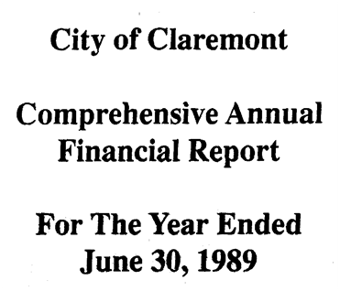
Fig. 6.34
Based on the information in Fig. 6.34, the cataloger has chosen to transcribe the "City of Claremont" as the statement of responsibility because the report is about the city.

110 | 1# | $a Claremont (Calif.)
245 | 10 | $a Comprehensive annual financial report for the year ended ... / $c City of Claremont.

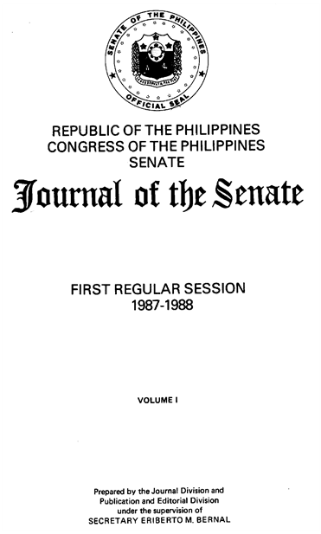
Fig. 6.35
Based on the information in Fig. 6.35, the cataloger has chosen to transcribe "Republic of the Philippines" as part of the statement of responsibility because it appears with the responsible body. A subsequent statement of responsibility is also given (see CCM 6.5.7.).

110 | 1# | $a Philippines. $b Congress. $b Senate.
245 | 10 | $a Journal of the Senate / $c Republic of the Philippines, Congress of the Philippines, Senate ; prepared by the Journal Division and Publication and Editorial Division.

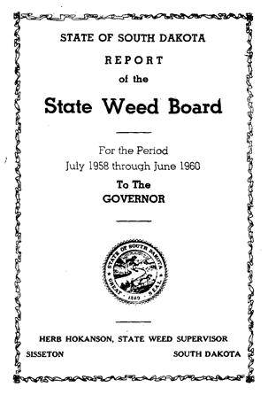
Fig. 6.36

In Fig. 6.36, "State of South Dakota" is not recorded as a statement of responsibility because it appears alone at the top of the page and the responsible body appears elsewhere (in the title).

110 | 1# | $a South Dakota. $b State Weed Board.
245 | 10 | $a Report of the State Weed Board for the period ...

6.5.5. Personal names
In practice, a person is generally not recorded in a statement of responsibility unless that person is also the creator (see CCM 4.6). Consider transcribing a personal name in a statement of responsibility generally only when it is clear that the person is the author of the text, there is no corporate body that is responsible for issuing the serial, and the author is recorded as the creator in the authorized access point for the serial.

Consider most persons given on serials to be editors or compilers. A person may be an editor or compiler even when the name is preceded by words such as "by" or "prepared by." Generally, do not record the names of editors or compilers in a statement of responsibility. However, according to the exception to instruction RDA 2.4.1.4, record a statement of responsibility identifying an editor of a serial if the name of the editor is considered an important means of identifying the serial.


Fig. 6.37

In Fig. 6.37, Alison Cooper is assumed to be an editor and the name is not recorded.

245 | 00 | $a U.S. business in South Africa.

If desired, an authorized access point can be provided for a person who has not been recorded in the statement of responsibility.

6.5.6. Titles of other serials
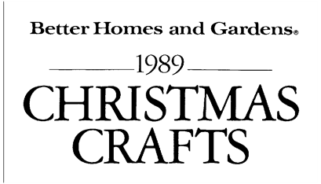
Fig. 6.38
The title of a serial cannot be a statement of responsibility for another serial because the title of a publication does not fit the definition of a responsible agent. If it is likely that someone might construe the title proper to begin with the title of the other serial, transcribe the title of the other serial in an "at head of title" note (field 500) and combine it with the title proper in field 246 to provide a variant title beginning with the name of the other serial (RDA 2.3.6.3).

245 | 00 | $a Christmas crafts.
246 | 1# | $a Better Homes and Gardens … Christmas crafts
500 | ## | $a At head of title: Better Homes and Gardens.

6.5.7. Subsequent statements of responsibility
Some serials present more than one statement that may be considered to be a statement of responsibility. Often a corporate body will appear at head of the title and a statement concerning the preparation of the serial will appear elsewhere on the source. In such cases, both statements may be transcribed, separated by a space-semicolon-space. The statements are recorded in the order in which they are presented on the source (RDA 2.4.1.6). (See Fig. 6.35)

245 | 00 | $a Journal of the Senate / $c Republic of the Philippines, Congress of the Philippines, Senate ; prepared by the Journal Division and Publication and Editorial Division.

6.6. Combining elements of the title statement
RDA does not instruct on combining descriptive elements but this CCM section can help you with the MARC subfields. See also examples in the CEG.

6.6.1. Common title/section title and other elements of the title statement

a. Other title information
If included in the title statement, transcribe other title information following the part of the title proper to which it refers.

245 | 04 | $a The Dacca University studies. $n Part-C : $b semi-annual journal of the Faculty of Commerce.
245 | 00 | $a Solar photovoltaics. $p Quarterly update : $b a bibliography with abstracts / $c prepared by ...

b. Statements of responsibility
A statement of responsibility is not required, but if desired, give it following the part of the title to which it refers.

245 | 00 | $a Corporation franchise tax. $p Number of corporations and reported tax liability by tax base / $c Ohio Department of Transportation.

6.6.2. Parallel titles proper and other elements of the title statement

a. Other title information
If transcribing other title information:

- Titles and other title information given in each language: transcribe the other title information following the title in the corresponding language.

245 | 00 | $a Narcotic drugs : $b estimated world requirements for ..., statistics for ... / $c International Narcotics Control Board, Vienna = Stupéfiants : évaluations des besoins du monde pour ... statistiques pour ... / Organe international de contrôle des stupéfiants, Vienne.

- Titles in more than one language and other title information in one language: transcribe after the title in the corresponding language only.

- Title in one language and other title information in more than one language: transcribe all of the other title information following the title proper.


Fig. 6.39

245 | 00 | $a Botanica acta : $b Berichte der Deutschen Botanischen Gesellschaft = Journal of the German Botanical Society.

b. Statements of responsibility
If transcribing the statement of responsibility:

- Title in more than one language, statement of responsibility in each language: transcribe each statement of responsibility after the title in the same language.

245 | 10 | $a Liste des membres / $c Association internationale de signalisation maritime = List of members / International Association of Lighthouse Authorities.

- Title in more than one language, statement of responsibility in one language: transcribe statement of responsibility after all of the parallel titles. (Fig. 6.46.)


Fig. 6.40

245 | 10 | $a Catalogo degli esportatori e degli importatori della provincia di Reggio Emilia = $b Catalogue of exporters and importers in the province of Reggio Emilia / $c Camera di commercio, industria, artigianato e aricoltura di Reggio Emilia.

- Title in one language, statements of responsibility in more than one language: transcribe only the statement in the language of the title proper.

REVUE

UNION INTERNATIONALE DES TRANSPORTS PUBLICS
INTERNATIONAL UNION OF PUBLIC TRANSPORT
INTERNATIONALER VEREIN FÜR ÖFFENTLICHES
VERKEHRSWESEN

Fig. 6.41

245 | 00 | $a Revue / $c Union internationale des transports publics.

c. Common title/section titles
- Transcribe the common title and section title that constitute the title proper followed by the parallel common titles and section titles.

245 | 00 | $a Archive für Meteorologie, Geophysik und Bioklimatologie. $n Ser. A, $p Meteorologie und Geophysik = $b Archives for meteorology, geophysics, and bioclimatology. $n Series A, $p Meteorology and geophysics.

6.7. Changes to elements of the title statement other than the title proper
Changes in the title proper ($a, $n, $p) may or may not require a new description and are treated separately in Module 16. Changes to other elements of the title statement are generally covered by notes (see also Module 13).

6.7.1. Other title information (RDA 2.3.4.7.2)

A change in other title information does not constitute a major change, i.e., it does not warrant the creation of a new description. In most cases, such a change is ignored, or a note, Subtitle varies, may be given. Do not give this note, however, if other title information has not been recorded in the title statement (245 $b). If the change is in the name of the responsible body, see CCM 6.7.3. below.

6.7.2. Parallel titles proper (RDA 2.3.3 and 2.3.3.5.2)

Parallel titles proper may be added or dropped on later issues, or their order may change. In other cases the wording of the parallel title may change. If considered to be important, record these changes as follows:

a. Added
Do not record in field 245. Transcribe in a variant access point (246 1# -- this field will display a note in most systems).

245 | 00 | $a Pulpwood and wood residue statistics.
246 | 1# | $i Volumes for 1969- have French title: $a Statistiques de bois à pâte et déchets de bois $g (title varies slightly)

b. Dropped
If a title that is recorded in field 245 $b is dropped on later issues, then give a note such as:

500 | ## | $a Issues for 1984-<1990> lack French title.

c. Order of parallel titles proper changed
If desired, give a note such as:

500 | ## | $a Order of titles varies.

d. Change in words
If the change affects only the parallel title proper, a general or explicit note may be given. More often a change to a parallel title proper also reflects a change to the title proper, in which case it must be determined whether a new description is needed. Give a variant access point (246) for changes to parallel titles proper that are noted explicitly.

General note

500 | ## | $a Title varies slightly.
[Both titles vary slightly]

Explicit note

245 | 00 | $a [English title] = $b [French title]
246 | 1# | $a Issues for 1987- give French title as: $a [variant French title]
246 | 11 | [French title]

6.7.3. Statement of responsibility (RDA 2.4.1.10.2)
If the corporate body given in the statement of responsibility changes its name or is replaced by another body and the authorized access point of the serial does not include the name of the body as its creator (in field 1xx) or as a qualifier for the serial’s preferred title (in field 130), then optionally record the new body in an issuing bodies note (field 550). See Module 13.

6.8. Further examples
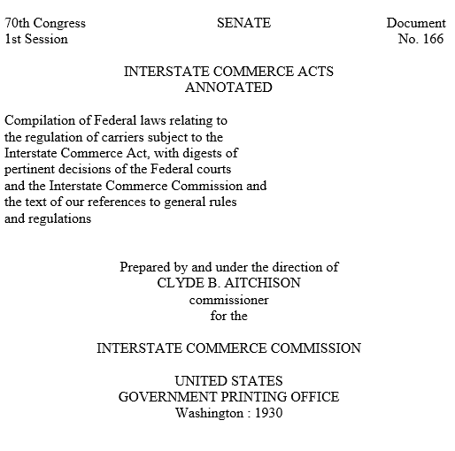
Fig. 6.42

There are two problems in this example (Fig. 6.42). The first is the extensive statement following the title. The cataloger has determined that the information is important and should be included in the record, but rather than record it as other title information and "clutter up" the title statement, the statement has been given in a quoted note (LC-PCC PS 2.3.4).

The second problem is the name of the commissioner in the statement of responsibility. The person named is a government official and the name is sure to change on future issues. The cataloger has chosen to omit the name and replace it with a mark of omission.

245 | 00 | $a Interstate commerce acts annotated / $c prepared by and under the direction of ... for the Interstate Commerce Commission.
500 | ## | $a “Compilation of Federal laws relating to the regulation of carriers subject to the Interstate Commerce Act, with digests of pertinent decisions of the Federal courts and the Interstate Commerce Commission, and the text of or references to general rules and regulations."

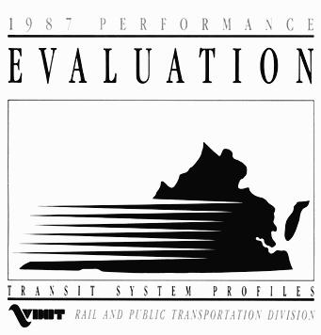 | 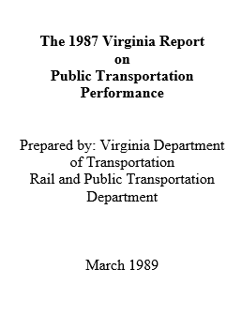
Fig. 6.43a. Cover | Fig. 6.43b. Title page
 | 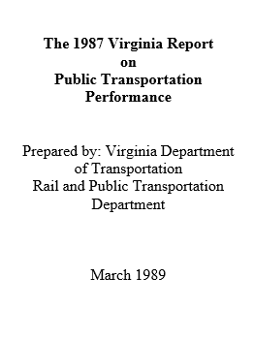
Fig. 6.43c. Cover | Fig. 6.43d. Title page

Which source should be used for the title? The two publications in Fig. 6.43 are identical in every way except for the statements "Transit system profiles," and "Summary of state transit statistics" which appear at the bottom of the cover and identify the exact nature of each publication. Although each publication has a title page, the titles given are identical and not sufficient to distinguish the two publications. The cataloger has applied the LC-PCC PS for RDA 2.2.2.2 and chosen the cover as the preferred source, constructing the title proper with the common title "Performance evaluation" and adding the section title from below. The title given on the title page is recorded as an "other title" in field 246.

245 | 00 | $a Performance evaluation. $p Transit system profiles.
246 | 1# | $a Transit system profiles
246 | 1# | $a Virginia report on public transportation performance
588 | ## | $a Description based on: 1987; title from cover.

245 | 00 | $a Performance evaluation. $p Summary of state transit statistics.
246 | 1# | $a Summary of state transit statistics
246 | 1# | $a Virginia report on public transportation performance
588 | ## | $a Description based on: 1987; title from cover.

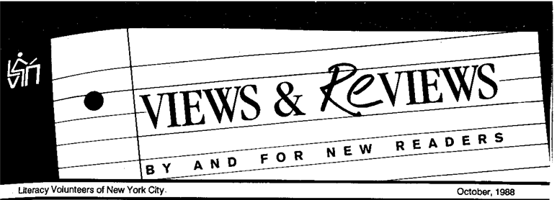
Fig. 6.44
Is "by and for new readers" part of the title proper or a statement of responsibility? While the "views & reviews" are by the readers, the publication itself is a product of the Literacy Volunteers of New York City. Thus, the cataloger has included the phrase as part of the title proper and transcribed the Volunteers as the statement of responsibility. An added entry is also given for the part of the title that is typographically prominent.

245 | 00 | $a Views & reviews by and for new readers / $c Literacy Volunteers of New York City.
246 | 1# | $a Views and reviews by and for new readers
246 | 1# | $a Views & reviews


Fig. 6.45

The titles in Fig. 6.45. pose a problem for the transcription of the parallel title proper. Neither "paper, film & foil" nor "converting technology" is a direct translation of the Japanese title Konbātekku, which is a word for "converting" derived from the English. RDA defines a parallel title as "a title proper in another language or script; an alternative title in another language or script is treated as part of a parallel title proper." The cataloger has determined that the words represent the publisher's choice of an English title for the serial (see also CCM 6.4.1). A second problem is the fact that the English phrases are separated by the Japanese title. Are these meant to be separate titles or one? Could one be a distinctive title? After examining other areas of the serial, the cataloger decided to record Paper, film & foil, converting technology as a parallel title proper in field 246 with indicators 11. The cataloger also transcribed Converting technology as a variant title.

245 | 00 | $a Konbātekku.
246 | 11 | $a Paper, film & foil, converting technology
246 | 1# | $a Paper, film and foil, converting technology
246 | 1# | $a Converting technology

Summary
Omissions from the title proper

- Numbers and dates that designate an issue of a serial
- Any other number or word that is likely to change with every, or almost every, issue
- Distinctive titles
- The earlier title of the serial or the title of an absorbed serial

Other title information

You should record in the title statement:
- Other title information that contains the statement of responsibility

Do not generally record:
- Subtitles that do not contain the statement of responsibility and add little to the understanding of the title

Consider recording in title statement or as a note:
- Subtitles that indicate the nature of the title when the title proper does not
- Titles other than the title proper

Consider recording as a summary (field 520) note:
- Explanatory text describing the nature of the resource when the title consists only of a corporate or conference name.

For inaccuracies, see the exception for serials to RDA 2.3.1.4.
Text for $i in this example taken from page 73 of Ed Jones’ book RDA and Serials Cataloging. We think that this wording is very helpful to the catalog user.
These guidelines also apply to omissions from other title information (when recorded).

